SIMATS ENGINEERING
NAME: A.Preetika Sudhakar
RREG NO. 192371073
COURSE NAME: Database Management Systems
COURSE CODE: CSA0501

Ex. No.: 8
Query with Sub Query & Correlated Query

Aim:
To perform subquery and correlated query on the given relations.

DESCRIPTION:
SUBQUERY
A MySQL subquery is a query nested within another query such as SELECT, INSERT, UPDATE or DELETE. In addition, a MySQL subquery can be nested inside another subquery.
A MySQL subquery is called an inner query while the query that contains the subquery is called an outer query. A subquery can be used anywhere that expression is used and must be closed in parentheses.
CORRELATED QUERY:
A correlated subquery is a subquery that uses the data from the outer query. In other words, a correlated subquery depends on the outer query. A correlated subquery is evaluated once for each row in the outer query.
SYNTAX:
SUBQUERY: SELECTc1, c2,...,cn
FROMtable
WHEREc1 IN (SELECTc1, c2,...,cn
FROMtable
WHEREwhere_conditions);
CORRELATED QUERY:
SELECT*
FROMtable_name
WHEREEXISTS (subquery );

Questions:

Sub-Query and Correlated Sub-Query:
1. Which of the student’s score is greater than the average score?
2. Which of the students’ have written more than one assessment test?
3. Which faculty has joined recently and when?
4. List the course and score of assessments that have the value more than the average score each Course.

OUTPUTS:
1. Which plots have price greater than the average price?
SELECT plot_no, price FROM plots WHERE price > (SELECT AVG(price) FROM plots);
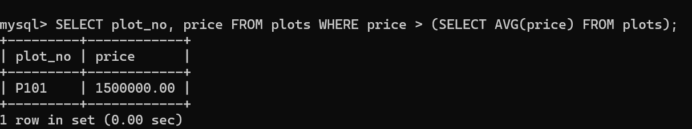

2. Which owners have purchased more than one plot?
SELECT owner_id FROM plots GROUP BY owner_id HAVING COUNT(*) > 1;

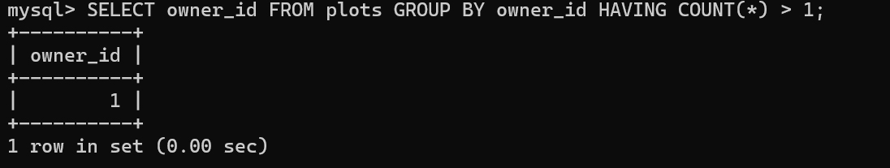

3. Which owner registered most recently and when?
SELECT owner_id, reg_date FROM registrations WHERE reg_date = (SELECT MAX(reg_date) FROM registrations);
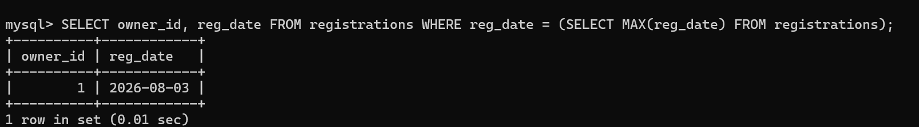
4. List plot and payment amount that are greater than the average payment amount for that plot (Correlated Query)
SELECT p1.plot_id, p1.amount FROM payments p1 WHERE p1.amount > ( SELECT AVG(p2.amount) FROM payments p2 WHERE p1.plot_id = p2.plot_id );

RESULT:
The records from the tables are displayed using Sub-Query and Correlated Sub-Query.

